|  |  |
| --- | --- |
|  |  |

|  |
| --- |
| **Activity 6.1.1 Atomic Structure & Electricity** |

Introduction

Why is electricity the preferred method for moving power? Electric lines connect buildings and homes. Within buildings and homes, lines carrying electricity run through almost every wall. The primary reason that electricity is everywhere is because it is easy to transport. Electricity flows between atoms with a simple push. It doesn’t take up much space or have any visible moving parts. Can you think of a way that power could be moved if electricity wasn’t available? What would it look like? How well would it work?

Procedure

This activity should be completed as the Atomic Structure and Electricity presentations are given.

1. Draw an atom with an atomic number of 12. Label the protons, neutrons, and electrons. Use the periodic table to identify which atom you have drawn.

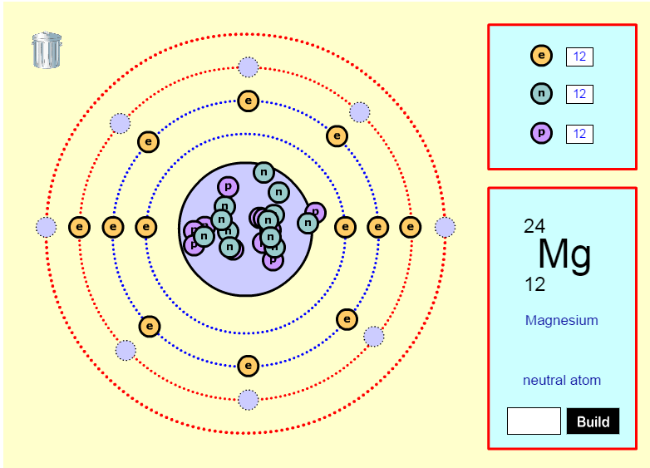

1. How many valence electrons are present in this atom?

2 valence electrons

1. Would this atom prefer to gain or lose electrons? Why?

Gain, because it has 1-3 valence electrons.

1. Describe the differences between conductors, semiconductors, and insulators.

Conductors conduct electricity easily, semi-conducts aren’t good insulators or conducts, and Insulators don’t conduct as well. Insulators usually have 5-8 valence electrons, semi-conductors have 4, and conductors usually have 1-3.

1. Use a different color to identify the metals, non-metals, and metalloids in the periodic table below. In each box list characteristics of each like-colored group of elements.

|  |  |  |
| --- | --- | --- |
| Element Group | Color | Characteristics |
| Metals |  | Good conductors, poor insulators, shiny, malleable, high density |
| Non-metals |  | Combination of metal and non-metals, conduct heat/electricity better than insulators, but not as good as metals, solids, semi-conductors |
| Metalloids |  | Poor conductors, good insulators, dull luster, brittle, low density, melt at lower temps |
|  | | |

Conclusion

1. Explain how being a metal, metalloid, or non-metal affects conductivity.

Metals are good conductors, have about 1-3 valence electrons. Non-metals are poor conductors, making them good insulators and have about 5-8 valence electrons. Metalloids are usually semiconductors, which aren’t good insulators or conductors and have 4 valence electrons.

1. Is the element Sulfur a metal or non- metal. Explain how you got your answer.

Non-metal, I looked at a periodic table and Sulfur is classified as a non metal.

1. In your own words, describe how electrons move between atoms to create electricity.

When a electrons collide and are transferred from one atom to another, electricity is created.